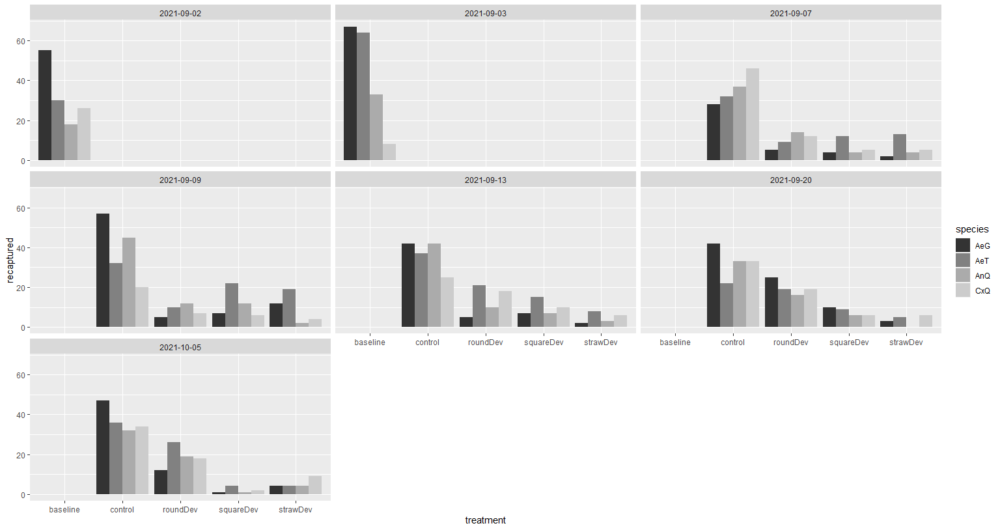

Updated chart with the most recent recaptures. This shows the baseline data for each tent and the recaptures for the treatment in each tent. SE_2_east is semi field enclosure 2 with the 2 man tent on the east side, this will be used as a permanent control going forward. SE_3_east is the straw transfluthrin device tent in enclosure 3, SE_3_west is the square transfluthrin device tent, SFEeast is the marine two man tent control, and SFEwest is the marine two man tent with the round device with slit.

Temperature profile for the Semi Filed enclosures at CMAVE. Date are means for 24-hour period on each day.

Updated chart showing the baseline recaptures and the replicate experiments with the tent entrance devices to date. This shows the baseline data for each tent and the recaptures for the treatment in each tent. SE_2_east is semi field enclosure 2 with the 2 man tent on the east side, this will be used as a permanent control going forward. SE_3_east is the straw transfluthrin device tent in enclosure 3, SE_3_west is the square transfluthrin device tent, SFEeast is the marine two man tent control, and SFEwest is the marine two man tent with the round device with slit.

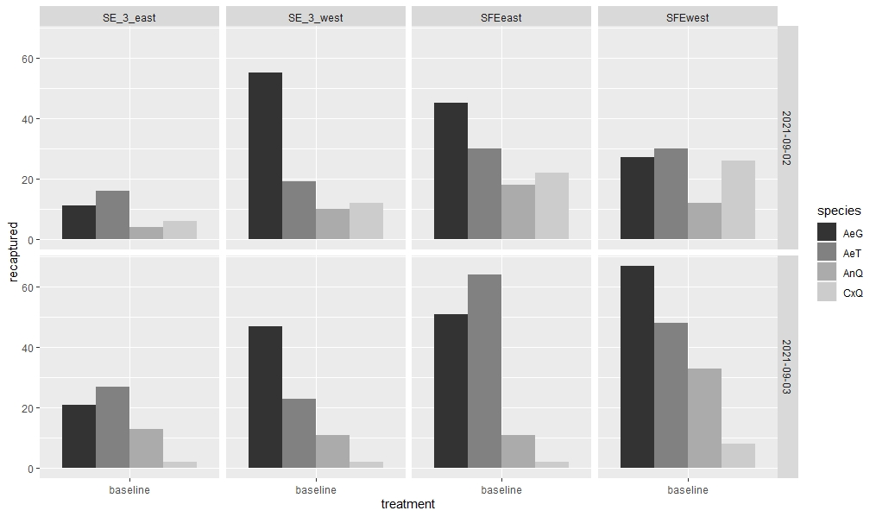

Two days of baseline collections. Locations were designated as Small Screened Fence Enclosure (SFE) East, SFE West, Screened Enclosure #3 (SE_3) East and (SE_3) West.

Treatments were randomly assigned to these four locations. As was done for the baseline, four species of mosquitoes were released into each enclosure: Aedes aegypti (AeG), Aedes taeniorhynchus (AeT), Culex quinquefasciatus (CxQ) and Anopheles quadrimaculatus (AnQ). 50 of each species were released into SFE East and SFE West; 100 of each species were released into Enclosures #3 and #2. Mosquitoes were recaptured by CDC traps baited with light and dry ice.

Comparison of each two man tent used in the experiment and baseline recaptures. This shows the baseline data for each tent and the recaptures for the treatment in each tent. SE_2_east is semi field enclosure 2 with the 2 man tent on the east side, this will be used as a permanent control going forward. SE_3_east is the straw transfluthrin device tent in enclosure 3, SE_3_west is the square transfluthrin device tent, SFEeast is the marine two man tent control, and SFEwest is the marine two man tent with the round device with slit. Baseline recaptures were done on 9/2/2021 and 9/3. First iteration of experiment was done on 9/7/2021.

Marine style two man tent with hanging tent entrance devices.

Army style two man tent with entrance devices.

Marine tent without entrance devices

**Environmental Data**

**9/7/2021**

Mean Temperature: 83.23oF

Mean Humidity: 72.31%

Mean Wind Speed: 0.075mph

Mean Wind Direction: 247.5deg (SW)